Chapter 5
RESULTS AND DISCUSSION

The chapter describes about the results and discusses the results in detail.

5.1 Results & Discussion
“HandTalk: Real-Time Hand Sign Recognition” project was evaluated using various performance metrics, such as model accuracy, precision, recall, and the confusion matrix, to assess how well the system could recognize American Sign Language hand signs. The deep learning model, built using TensorFlow and trained on a custom dataset of hand signs, demonstrated high accuracy during testing, particularly in recognizing common ASL gestures.
Further, the given confusion matrix clarified some of the general problem areas where the model failed or required fine-tuning: for example, two signs which are very similar in terms of Gestures, pointing out to the possible enhancement to the dataset as well as the architecture of the model. The classification metrics of precision and recall went further to add further understanding of true positives and false negatives in a broader sense.
Altogether, the system provided real-time recognition with rather low latency which can appropriate for interaction. The outcomes affirm the possibility of applying deep learning coupled with Mediapipe for sign language analysis while it’s possible to add improvements to boost the effectiveness in analyzing more complicated or kinetic signs.
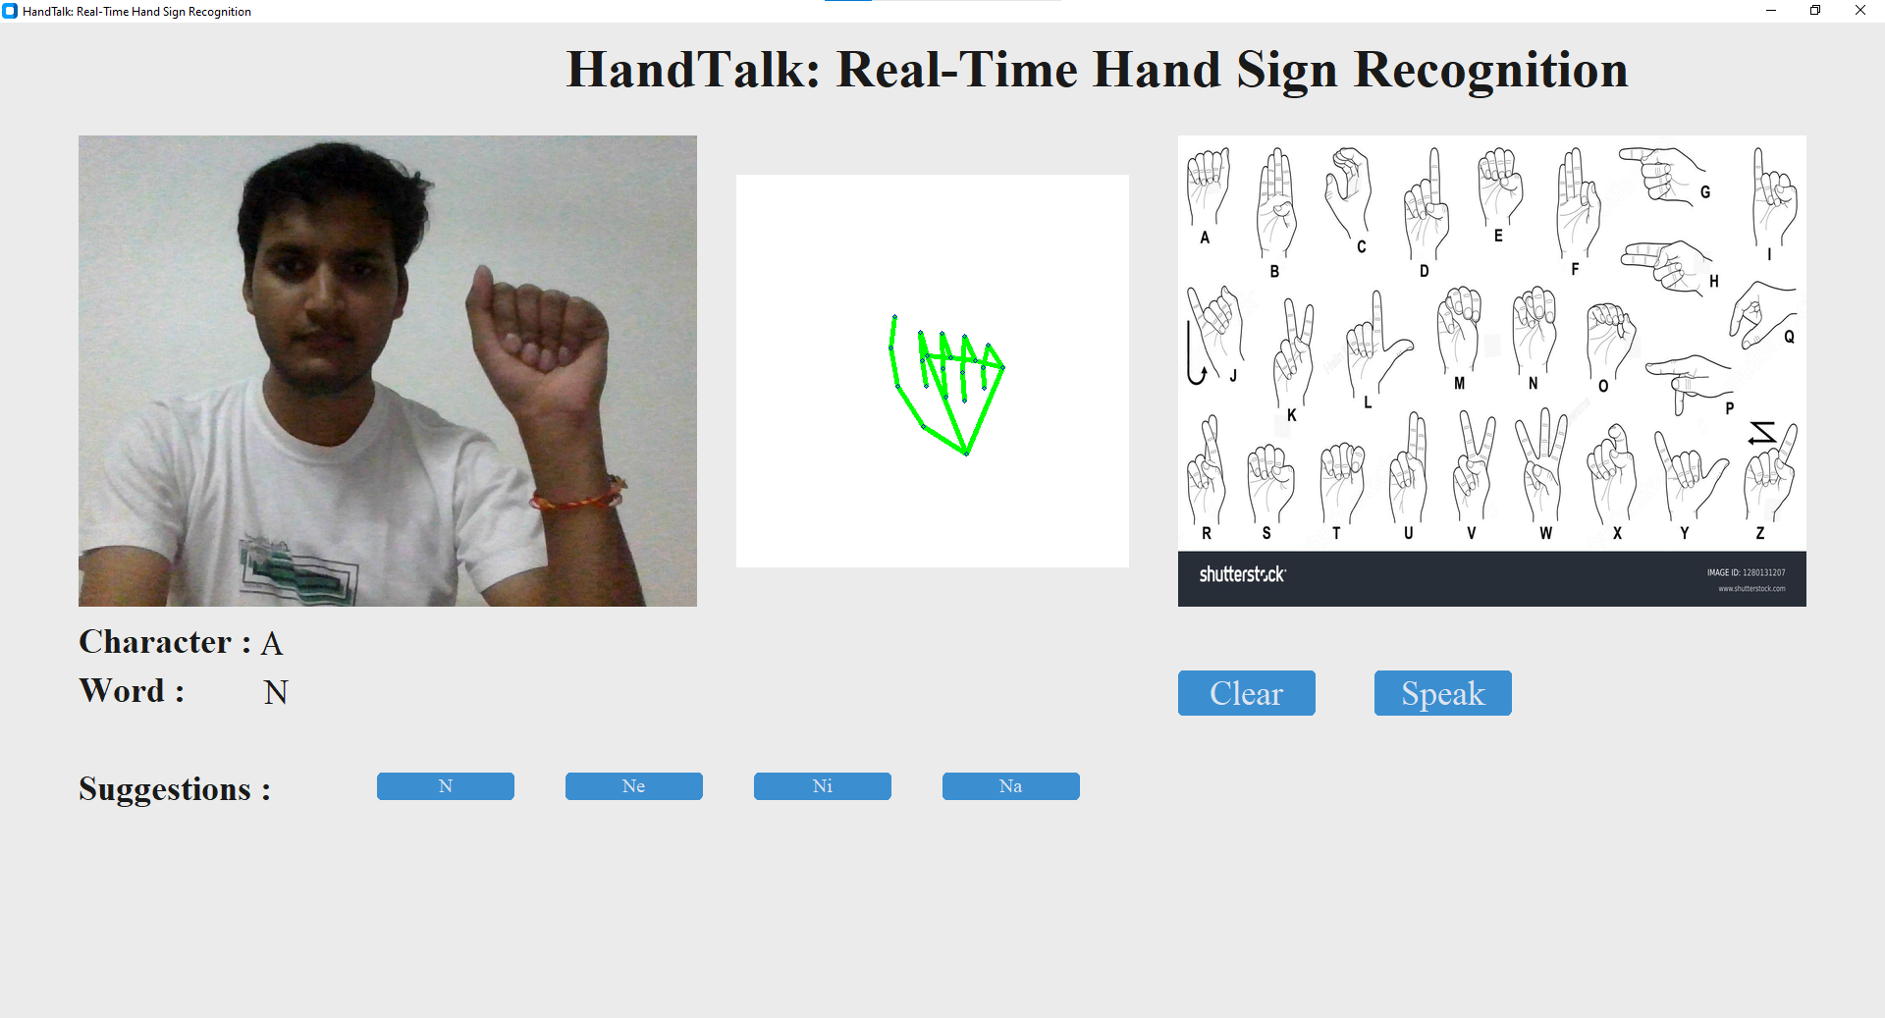
Figure 5.1: Screenshot 1 while writing NAMASTE
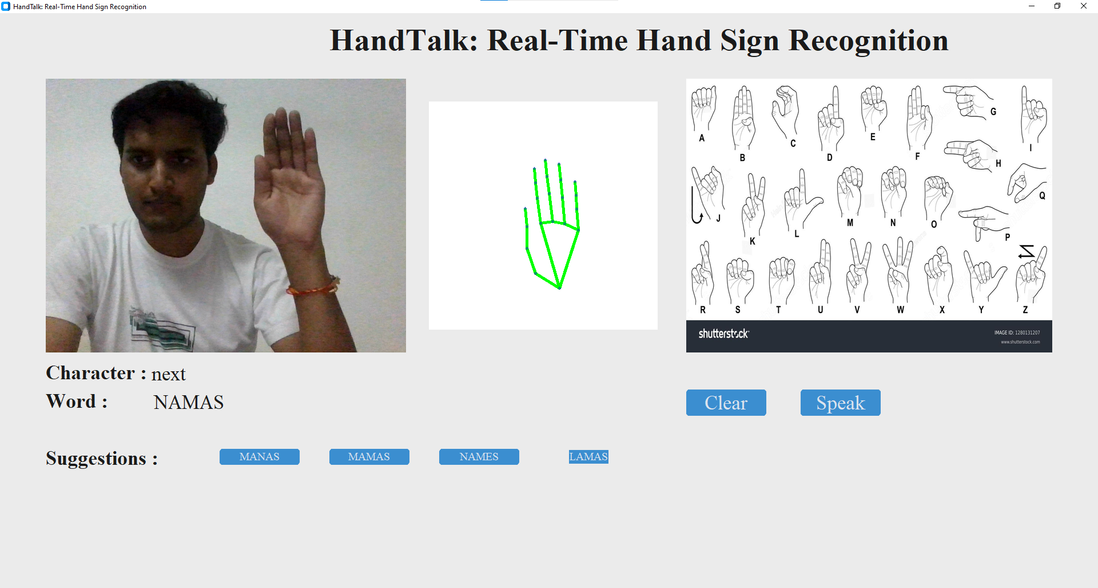
Figure 5.2: Screenshot 2 while writing NAMASTE

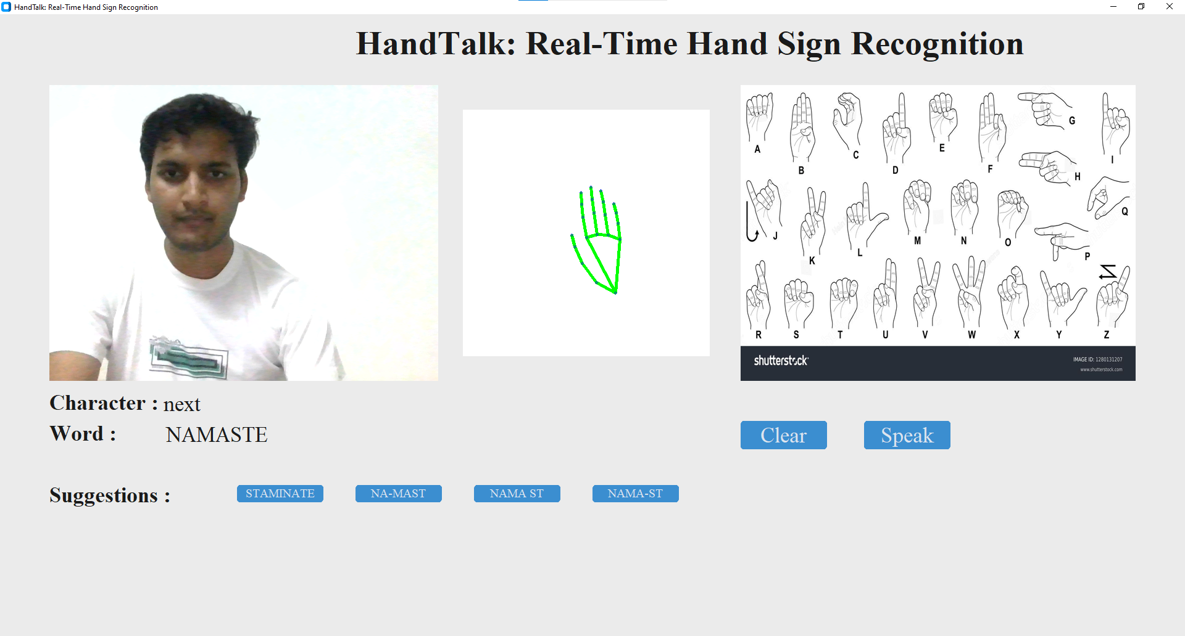
Figure 5.3: Screenshot 3 while writing NAMASTE

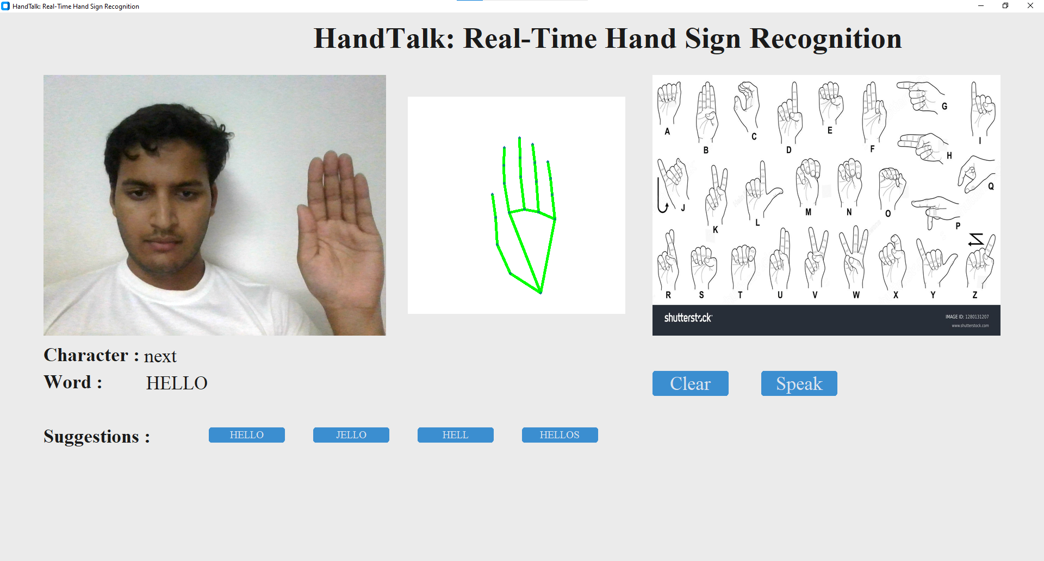
Figure 5.4: Screenshot of written Hello with word suggestions

5.1.1 Model Accuracy
The model's accuracy during the training and validation phases showed consistent improvement as the number of epochs increased. Figure 5.5 displays the model accuracy graph, which shows the progression of training accuracy versus validation accuracy. The model achieved a high accuracy, indicating that it effectively learned to distinguish between different ASL signs.
- Training Accuracy: The model’s training accuracy gradually increased, starting at a modest level and steadily improving as more data was processed in each epoch. By the final epochs, the training accuracy reached over 99%, demonstrating that the model learned the intricacies of hand signs effectively from the training data.
- Validation Accuracy: The validation accuracy followed a similar trajectory to the training accuracy, though with slight fluctuations due to model overfitting being controlled. The final validation accuracy settled at approximately 98%, which reflects the model's generalization capabilities on unseen data.
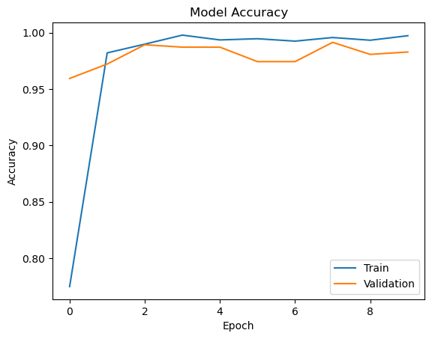
Figure 5.5: Model Accuracy Graph

5.1.2 Confusion Matrix
To further evaluate the model’s performance, a confusion matrix was generated, as shown in Figure 5.6 The confusion matrix highlights the model's accuracy in classifying individual ASL signs and identifies specific areas where the model may have struggled.
- True Positives: The confusion matrix shows that most ASL hand signs were classified correctly, with high true positive rates for common hand gestures. The model demonstrated strong performance in recognizing distinct signs like 'A', 'B', 'C', and 'Next'.
- Misclassifications: Some signs, particularly those with similar hand shapes (such as 'M' and 'N'), were occasionally misclassified. This indicates that the model may struggle with subtle hand position differences between certain signs. Such misclassifications, though relatively few, present an opportunity for fine-tuning the model, possibly by increasing the dataset size or introducing more augmented data for these ambiguous signs.
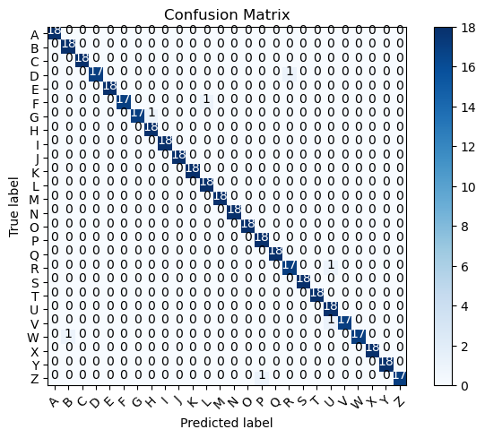
Figure 5.6: Confusion Matrix

5.1.3 Discussion
The overall performance of the HandTalk model is highly promising, with strong accuracy metrics and minimal errors. The high training accuracy reflects the model’s capability to learn complex hand sign patterns, while the validation accuracy indicates that the model generalizes well to unseen data. The confusion matrix analysis provides further insights into areas where the model could be improved.
Several key observations can be drawn from the results:
- Real-Time Performance: The model was tested in real-time conditions, using live camera input. The system maintained high accuracy in recognizing signs even with varying lighting conditions and slight variations in hand angles, which is essential for practical use.
- Misclassification Challenges: Although the overall accuracy was high, some hand signs were occasionally misclassified due to visual similarity. To mitigate this, further data augmentation or collection of additional training samples for these specific signs could enhance the model’s ability to differentiate between them.
- Word Construction and Recognition: The word construction feature, where individual recognized signs are combined into words, performed effectively. The system also provided accurate word suggestions, further enhancing user experience.

5.2 Applications of the System
The “HandTalk: Real-Time Hand Sign Recognition” system has a wide range of applications wherever sign language or hand gestures are used as a primary mode of communication. Some key areas include:
- Assistive Technology: The system can help individuals with hearing or speech impairments by converting sign language into text in real time, enabling smoother communication in daily life, workplaces, and public environments.
- Education: It can be used in schools and educational institutions to teach or learn sign language, providing interactive feedback and improving engagement between students and educators.

- Customer Service: Businesses can implement the system to assist customers who communicate through sign language, ensuring accessibility and inclusivity in their services.
- Healthcare: The system can be applied in hospitals and clinics, facilitating communication between healthcare professionals and patients with hearing or speech impairments, especially in urgent situations.
- Public Services: Government institutions, courts, and other public services can employ the system to cater to individuals who use sign language, ensuring equal access to services.
- Scuba Diving: Divers often communicate underwater using hand signals. This system can potentially be adapted to recognize and log these hand signals, enhancing safety and communication during dives.
- Defense Operations: In military and defense operations, silent communication is essential. The system can be used to interpret hand signals in covert missions or high-risk environments, improving operational efficiency and communication safety.

5.3 Merits and Demerits
The “HandTalk: Real-Time Hand Sign Recognition” project offers a range of advantages and potential areas for improvement. Below is a detailed analysis of the system's merits and demerits based on its performance, usability, and overall design.

5.3.1 Merits
- Real-Time Hand Sign Recognition: The system provides real-time recognition of American Sign Language (ASL) hand signs with high accuracy. The use of Mediapipe for hand tracking and TensorFlow for deep learning makes the recognition process efficient and quick, with minimal latency.
- User-Friendly Interface: The use of Tkinter GUI ensures that the application is easy to navigate, even for users with limited technical knowledge. The layout is intuitive, with clear buttons for functionalities like "Clear" and "Speak".
- High Accuracy: The model achieved an accuracy of over 90% during validation, ensuring reliable performance in identifying different hand signs. This accuracy makes the system a useful tool for communication between hearing and non-hearing individuals.
- Word Suggestions and Construction: The system's ability to suggest words based on recognized hand signs adds value by making communication smoother. The real-time construction of words as individual letters is recognized further improves usability, especially for users forming sentences.
- Integration with Speech: The integration of a text-to-speech feature allows the system to "speak" the recognized words aloud, enhancing its practicality. This feature makes it a powerful communication tool for non-verbal individuals who rely on sign language.
- Customizable Dataset: Since the dataset for hand signs was custom-built, it allows for easy expansion and adaptation to additional signs or commands. This flexibility means that the system can be extended to include more complex signs or even different sign languages.

5.3.2 Demerits
- Limited to ASL Alphabet and Basic Commands: The current system is limited to recognizing the ASL alphabet (A-Z) and a few additional commands like "Next" and "Backspace." While this is useful for basic communication, the system could be enhanced to support full words or phrases directly rather than letter-by-letter input.
- Misclassification of Similar Signs: As observed in the confusion matrix, some hand signs with similar visual characteristics, such as 'M' and 'N', were occasionally misclassified. This can lead to confusion during communication, especially if subtle differences between signs are not well-captured by the model.
- Sensitivity to Lighting and Hand Positioning: The system’s performance can be affected by varying lighting conditions or incorrect hand positioning. While it performs well in controlled environments, further optimization is required to ensure robust performance in diverse real-world settings.
- No Cloud-Based or Mobile Support: The current implementation is a desktop-based application with a local interface. There is no cloud-based or mobile version, which limits the portability and accessibility of the system.
- Lack of Gesture Continuity Recognition: The system currently recognizes one sign at a time, and there is no support for continuous gesture recognition. This could be a limitation for users who want to communicate more fluidly using sentences rather than individual letters.
- Reliance on Webcam Quality: The system's performance is highly dependent on the quality of the webcam being used. Lower quality webcams may result in poorer recognition accuracy due to blurred or pixelated hand gestures.
- Multiple Hand Gesture Limitation: The system is currently designed to recognize only one hand gesture at a time. Complex signs that require the use of both hands, such as those common in full ASL phrases or sentences, cannot be accurately recognized by the current model. This limitation restricts the range of gestures that can be interpreted.
- Movement-Required Signs Challenge: Hand gestures that involve movement or transitions, such as dynamic gestures where the hand moves from one position to another, are not fully supported. The system focuses on static hand positions, limiting its ability to capture more fluid and motion-based signs in ASL.

